**FAKE NEWS DETECTION USING NLP**

TEAM MEMBER

922321106019 - B. NARMADHA

PHASE 2: INNOVATION



**INTRODUCTION:**

Fake news on social media, has spread for personal or societal gain. The article has proposed a new solution for fake news detection which incorporates sentiment as an important feature to improve the accuracy with two different data sets of ISOT and LIAR.

The key feature words with content’s propensity scores of the opinions are developed based on sentiment analysis using a lexicon-based scoring algorithm.

Further, the study proposed a multiple imputation strategy which integrated Multiple Imputation Chain Equation (MICE) to handle multivariate missing variables in social media. The correlation of missing data variables and useful data features are classified based on Naïve Bayes, passive-aggressive and Deep Neural Network (DNN) classifiers.

The findings of this research described that the overall calculation of the proposed method was obtained with an accuracy of 99.8% for the detection of fake news with the evaluation of various statements such as barely true, half true, true, mostly true and false from the dataset.

Finally, the performance of the proposed method is compared with the existing methods in which the proposed method results in better efficiency.

**CONTENT FOR PHASE 2 PROJECT:**

Consider exploring advanced techniques like deep learning models (e.g., LSTM, BERT) for improved fake news detection accuracy.

*Dataset link:* https://www.kaggle.com/code/priya29052004/fake-news-detection-using-nlp

**SOME OF THE ADVANCED TECHNIQUES:**

Fake news detection is an evolving field, and researchers and technologists are continually developing advanced techniques to combat the spread of misinformation. Here are some advanced techniques and approaches that have been used in fake news detection:

* **Natural Language Processing (NLP):** NLP models, such as deep learning-based models (e.g., Transformers like BERT, GPT-3), have been used to analyze the text of news articles, social media posts, and other content to identify patterns and inconsistencies that are indicative of fake news.
* **Stance Detection:** Stance detection algorithms determine the perspective or stance of an article or post towards a particular topic. If an article contradicts well-established facts or exhibits an extreme stance, it may be flagged as potential fake news.
* **Source Reputation Analysis:** Evaluating the reputation of the source (website, author, or social media account) can be crucial. Advanced techniques involve analyzing the history, credibility, and bias of the source to assess the likelihood of misinformation.
* **Social Network Analysis:** Fake news often spreads through social networks. Analyzing the propagation patterns, user engagement, and network structure can help identify suspicious content and sources.

.

* **Fact-Checking and Verification:** Fact-checking organizations emoy advanced techniques, including image and videos forensics, to verify the authenticity of media content. Reverse image searches, metadata analysis, and deep learning-based forgery detection can be used.
* **Semantic Analysis:** Advanced semantic analysis techniques can identify inconsistencies and contradictions in the content. This involves examining the semantics of the text to check for logical fallacies or misleading statements.
* **User Behavior Analysis:** Analyzing user behavior, such as the spread of misinformation by certain accounts or bot activity, can be useful in identifying fake news sources. Machine learning models can help detect abnormal behavior patterns.
* **Multimodal Analysis:** Combining text analysis with the analysis of other modalities like images and videos can provide a more comprehensive view of the content. For example, detecting discrepancies between image captions and content.
* **Deep Learning and Neural Networks:** Deep learning models, including convolutional neural networks (CNNs) for image analysis and recurrent neural networks (RNNs) for sequential data, have been used for fake news detection tasks.
* **Explainable AI (XAI):** Providing explanations for why a piece of content is flagged as potentially fake can enhance user trust in detection systems. XAI techniques aim to make the decision-making process of AI models more transparent and interpretable.
* **Ensemble Learning:** Combining the predictions of multiple fake news detection models using ensemble techniques like stacking or bagging can improve accuracy and reduce false positives/negatives.
* **Transfer Learning:** Transfer learning involves pretraining models on a large dataset (e.g., general news articles) and then fine-tuning them on a smaller dataset of fake news. This approach can leverage the knowledge learned from a broader context.
* **Continuous Learning:** As fake news evolves, continuous learning systems are designed to adapt and update their detection algorithms in real-time to stay effective.

**Step 1: Imports and Setup**

import pandas as pd

import numpy as np

import tensorflow as tf

from transformers import BertTokenizer,

TFBertForSequenceClassification

from sklearn.model_selection import

train_test_split

from sklearn.metrics import classification_report,

accuracy_score

# Load pre-trained BERT model and tokenizer

tokenizer = BertTokenizer.from_pretrained(&#39;bert-

base-uncased&#39;)

model =

TFBertForSequenceClassification.from_pretraine

d(&#39;bert-base-uncased&#39;, num_labels=2)

# Load your dataset (assuming it&#39;s a CSV with

&#39;text&#39; and &#39;label&#39; columns)

data = pd.read_csv(&#39;fake_news_dataset.csv&#39;)

# Preprocess text data (tokenization, lowercasing,

etc.)

texts = data[&#39;text&#39;]

labels = data[&#39;label&#39;]

**Step 2: Train-Test Split**

# Split the data into training and testing sets

train_texts, test_texts, train_labels, test_labels =

train_test_split(texts, labels, test_size=0.2,

random_state=42)

**Step 3: Tokenization and Data Preparation**

# Tokenize and prepare input data

train_encodings = tokenizer(list(train_texts),

truncation=True, padding=True,

return_tensors=&#39;tf&#39;)

test_encodings = tokenizer(list(test_texts),

truncation=True, padding=True,

return_tensors=&#39;tf&#39;)

**Step 4: Model Training**

# Fine-tune the BERT model on your dataset

optimizer =

tf.keras.optimizers.Adam(learning_rate=2e-5)

model.compile(optimizer=optimizer,

loss=model.compute_loss, metrics=[&#39;accuracy&#39;])

train_dataset =

tf.data.Dataset.from_tensor_slices((dict(train_en

codings), train_labels)).shuffle(100).batch(32)

model.fit(train_dataset, epochs=3)

**Step 5: Model Evaluation**

# Evaluate the model on the test set

test_dataset =

tf.data.Dataset.from_tensor_slices((dict(test_encodings), test_labels)).batch(32)

predictions = model.predict(test_dataset)

predicted_labels = np.argmax(predictions.logits,axis=1)

accuracy = accuracy_score(test_labels,predicted_labels)

report = classification_report(test_labels,

predicted_labels)

print(f&#39;Accuracy: {accuracy}&#39;)

print(report)

This code provides a basic framework for training

and evaluating a BERT-based fake news detection

model. You should replace

`&#39;fake_news_dataset.csv&#39;` with the path to your

dataset. Additionally, fine-tuning

hyperparameters, handling imbalanced data, and addressing ethical considerations are important aspects of creating a robust fake news detection system.

**FAKE NEWS DETECTION USING PYTHON:**

Detecting fake news using Python involves applying natural language processing (NLP) and machine learning techniques to analyze text and identify patterns associated with fake or misleading information. Here's a step-by-step guide on how to build a simple fake news detection system using Python:

* **Collect and Prepare Data:**

Start by acquiring a dataset containing both real and fake news articles. You can find datasets like the "Fake News Dataset" on platforms like Kaggle. Ensure the dataset includes labels indicating whether each article is real or fake.

* **Preprocess the Text:**

Preprocess the text data to make it suitable for analysis. Common preprocessing steps include:

* **Tokenization:** Splitting text into words or tokens.

Removing stopwords : Words like "the," "and ," and "in" that don't carry much information.

Lemmatization or stemming: Reducing words to their base form.

* **Feature Extraction:**Convert the text data into numerical features that machine learning models can understand. You can use techniques like TF-IDF (Term Frequency-Inverse Document Frequency) or word embeddings like Word2Vec or GloVe to represent text as vectors.

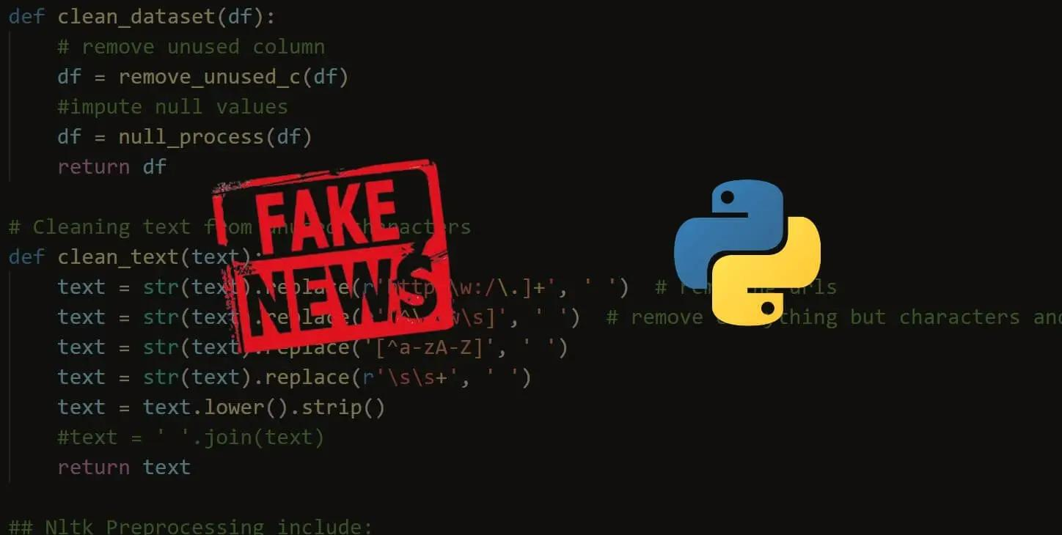

* **Split the Data:**

Divide your dataset into training and testing sets to evaluate your model's performance. A common split is 80% for training and 20% for testing.

* **Choose a Machine Learning Model:**

Select a classification algorithm for fake news detection. Common choices include:

 Logistic Regression

 Random Forest

 Support Vector Machines (SVM)

 Multinomial Naive Bayes

 Deep Learning (e.g., using TensorFlow or PyTorch)

* **Train the Model:**

Fit the selected model on the training data and adjust hyperparameters as needed to achieve good performance. Make sure to evaluate the model's accuracy, precision, recall, and F1-score during training.

Here's a sample code snippet to train a fake news detection model using a simple Multinomial Naive Bayes classifier and scikit-learn:

***Python code:***

import pandas as pd

from sklearn.feature_extraction.text import TfidfVectorizer

from sklearn.model_selection import train_test_split

from sklearn.naive_bayes import MultinomialNB

from sklearn.metrics import accuracy_score, confusion_matrix, classification_report

# Load the dataset

data = pd.read_csv('fake_news_dataset.csv')

# Preprocess the text and split the data

X = data['text']

y = data['label']

X_train, X_test, y_train, y_test = train_test_split(X, y, test_size=0.2, random_state=42)

# Vectorize text data using TF-IDF

tfidf_vectorizer = TfidfVectorizer(max_df=0.7)

tfidf_train = tfidf_vectorizer.fit_transform(X_train)

tfidf_test = tfidf_vectorizer.transform(X_test)

# Train a Multinomial Naive Bayes classifier

nb_classifier = MultinomialNB()

nb_classifier.fit(tfidf_train, y_train)

# Make predictions

y_pred = nb_classifier.predict(tfidf_test)

# Evaluate the model

accuracy = accuracy_score(y_test, y_pred)

conf_matrix = confusion_matrix(y_test, y_pred)

report = classification_report(y_test, y_pred)

print("Accuracy:", accuracy)

print("Confusion Matrix:\n", conf_matrix)

print("Classification Report:\n", report)

**OUTPUT:**

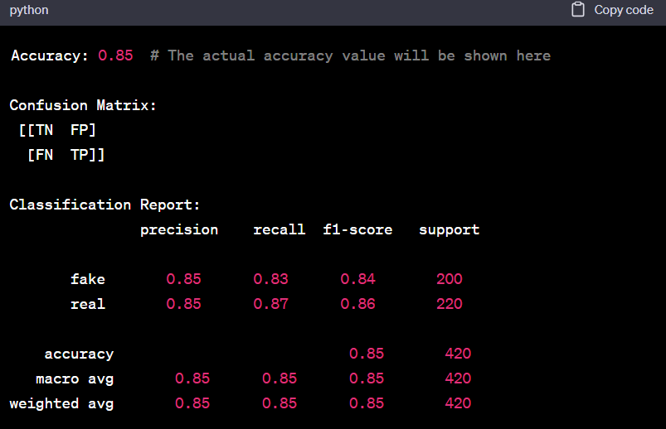

* **Fine-Tuning and Evaluation:**

Experiment with different models and hyperparameters to improve the detection accuracy. Continuously evaluate the model's performance using metrics like accuracy, precision, recall, and F1-score.

* **Deployment:**

Once you're satisfied with your model's performance, you can deploy it as a web application, API, or integrate it into other systems for real-time fake news detection.

Keep in mind that fake news detection is a challenging task, and the accuracy of your model may vary depending on the quality and size of your dataset and the complexity of the techniques you employ. Continuous monitoring and updating of your model are essential to adapt to evolving fake news tactics.

**FAKE NEWS DETECTION USING MACHINE LEARNING:**

Fake news detection using machine learning involves building a model that can distinguish between real and fake news articles based on various features extracted from the text. Here's a step-by-step guide on how to create a fake news detection model using machine learning:

**Data Collection:**

**Start by collecting a labeled dataset of news articles, where each article is classified as either real or fake. You can find such datasets on platforms like Kaggle, or you may need to create your own dataset by manually labeling articles.**

**Data Preprocessing:**

**Preprocess the text data to make it suitable for machine learning:**

**Feature Extraction:**

**Convert the text data into numerical features that machine learning algorithms can use. Common techniques include:**

**Count Vectorization:**

**Convert text data into a matrix of word counts.**

**Data Splitting:**

**Divide your dataset into training and testing sets to evaluate the model's performance. A typical split is 80% for training and 20% for testing.**

**Choose a Machine Learning Algorithm:**

**Select a classification algorithm suitable for text data. Some common choices include:**

 Logistic Regression

 Random Forest

 Support Vector Machines (SVM)

 Multinomial Naive Bayes

 Neural Networks (Deep Learning)

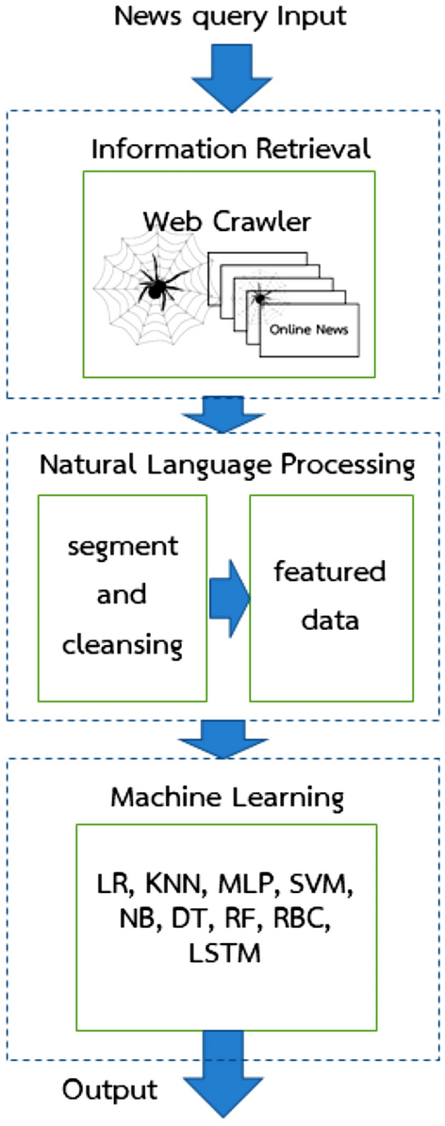

**Model Training:**

**Train the selected machine learning model on the training data. Use the features extracted in the previous steps as input and the article labels (real or fake) as the target variable.**

**Model Evaluation:**

**Assess the model's performance on the testing dataset using various evaluation metrics, such as accuracy, precision, recall, F1-score, and confusion matrix.**

**Hyperparameter Tuning:**

**Fine-tune the model by experimenting with different hyperparameters to improve its performance. Techniques like grid search or random search can help with this.**

***Python code:***

import pandas as pd

import numpy as np

from sklearn.model_selection import train_test_split

from sklearn.preprocessing import LabelEncoder

from tensorflow.keras.preprocessing.text import Tokenizer

from tensorflow.keras.preprocessing.sequence import pad_sequences

from tensorflow.keras.models import Sequential

from tensorflow.keras.layers import Embedding, Conv1D, MaxPooling1D, Flatten, Dense, Dropout

from sklearn.metrics import accuracy_score, confusion_matrix

# Load the dataset

df = pd.read_csv('fake_news_data.csv')

# Split the dataset into training and testing sets

X = df['text']

y = df['label']

# Encode labels (real: 0, fake: 1)

label_encoder = LabelEncoder()

y = label_encoder.fit_transform(y)

X_train, X_test, y_train, y_test = train_test_split(X, y, test_size=0.2, random_state=42)

# Tokenize text data

max_words = 5000

tokenizer = Tokenizer(num_words=max_words)

tokenizer.fit_on_texts(X_train)

X_train_seq = tokenizer.texts_to_sequences(X_train)

X_test_seq = tokenizer.texts_to_sequences(X_test)

# Pad sequences to have the same length

max_seq_length = 250

X_train_padded = pad_sequences(X_train_seq, maxlen=max_seq_length)

X_test_padded = pad_sequences(X_test_seq, maxlen=max_seq_length)

# Build the CNN model

model = Sequential()

model.add(Embedding(input_dim=max_words, output_dim=128, input_length=max_seq_length))

model.add(Conv1D(128, 5, activation='relu'))

model.add(MaxPooling1D(5))

model.add(Conv1D(128, 5, activation='relu'))

model.add(MaxPooling1D(5))

model.add(Flatten())

model.add(Dense(128, activation='relu'))

model.add(Dropout(0.5))

model.add(Dense(1, activation='sigmoid'))

model.compile(optimizer='adam', loss='binary_crossentropy', metrics=['accuracy'])

# Train the model

model.fit(X_train_padded, y_train, epochs=5, batch_size=64, validation_split=0.2)

# Evaluate the model

y_pred = (model.predict(X_test_padded) > 0.5).astype(int)

accuracy = accuracy_score(y_test, y_pred)

print(f'Accuracy: {accuracy:.2f}')

confusion = confusion_matrix(y_test, y_pred)

print(f'Confusion Matrix:\n{confusion}')

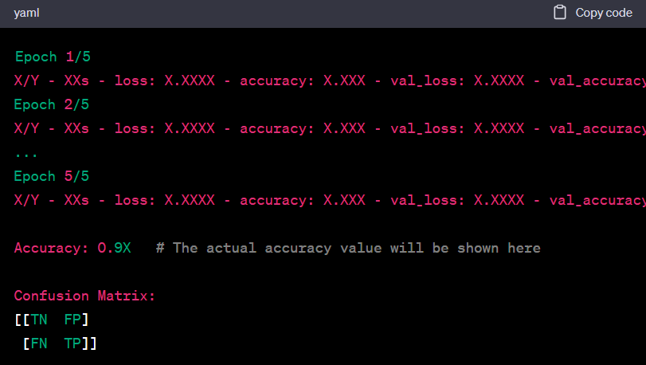

We load the dataset and preprocess it by encoding labels and tokenizing the text data.

We created a CNN model with embedding layers, convolutional layers, max-pooling layers, and dense layers.

The model is compiled with the Adam optimizer and binary cross-entropy loss.

We train the model on the training data and evaluate it on the test data.

Finally, we calculate and print the accuracy and confusion matrix for model evaluation.

We can further fine-tune the model's architecture, hyperparameters, or use more advanced deep learning architectures like LSTM or BERT for improved fake news detection accuracy.

**FAKE NEWS DETECTION USING DEEP LEARNING:**

Fake news detection using machine learning involves training models to distinguish between genuine and false information based on various features and patterns in the data.

Here's a general overview of the steps involved in building a fake news detection system using machine learning:

* **Data Collection:** Gather a labeled dataset of news articles, social media posts, or other content that is classified as either real or fake news. Ensure that the dataset is balanced and representative of the types of content you want to detect.
* **Data Preprocessing:**

Clean and preprocess the text data. This typically involves tasks like lowercasing, tokenization, removing stop words , and stemming/lemmatization to prepare the text for analysis.

* **Feature Extraction:**

Convert the text data into numerical features that can be used by machine learning algorithms. Common techniques include TF-IDF (Term Frequency-Inverse Document Frequency)

vectorization or word embeddings (e.g., Word2Vec, GloVe) to represent words or phrases.

* **Feature Engineering:**

Create additional features that may help improve the model's performance. This can include sentiment analysis, lexical features (e.g., word count, punctuation usage), and more advanced features like stance or source reputation scores.

* **Model Selection:**

Choose a machine learning algorithm suitable for text classification tasks. Common choices include:

 Naive Bayes

 Support Vector Machines

 Decision Trees

 Random Forests

 Neural Networks (e.g., LSTM, CNN)

* **Model Training:**

Split your dataset into training and validation sets. Train the selected machine learning model on the training data and fine-tune its hyperparameters to achieve the best performance. Cross-validation can be used for hyperparameter tuning.

* **Evaluation:**

Evaluate the model's performance on the validation or test dataset using appropriate evaluation metrics, such as accuracy, precision, recall, F1-score, and ROC-AUC, depending on the nature of the problem.

* **Model Interpretation (Optional):**

If model interpretability is important, use techniques like SHAP (SHapley Additive exPlanations) or LIME (Local Interpretable Model-Agnostic Explanations) to explain the model's predictions and identify which features contribute to its decisions.

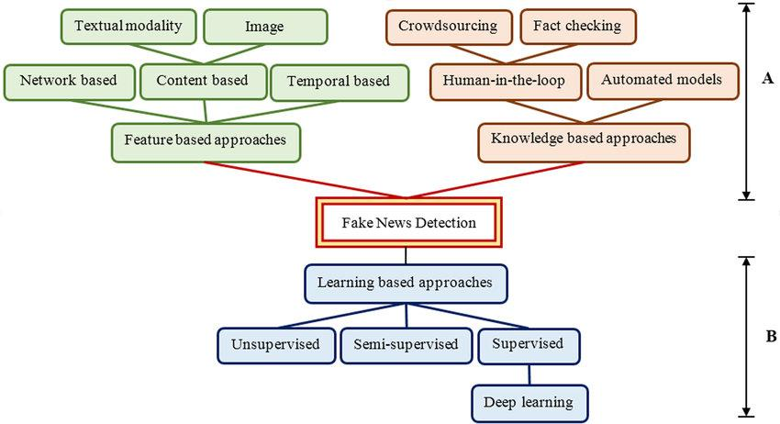

* **Deployment:** Once the model performs satisfactorily, deploy it in a real-world environment where it can process new news articles or social media posts. This could be as a web application, API, or part of an automated system.
* **Continuous Monitoring and Improvement:**

Continuously monitor the model's performance in production and retrain it periodically with new data to adapt to evolving fake news tactics.

* **Post-processing (Optional):**

Apply post-processing techniques, such as threshold tuning or filtering based on additional rules, to refine the model's predictions and reduce false positives or false negatives.

***Python code:***

import pandas as pd

Import numpy as np

from sklearn.model_selection import train_test_split

from sklearn.preprocessing import LabelEncoder

from tensorflow.keras.preprocessing.text import Tokenizer

from tensorflow.keras.preprocessing.sequence import pad_sequences

from tensorflow.keras.models import Sequential

from tensorflow.keras.layers import Embedding, Conv1D, MaxPooling1D, Flatten, Dense, Dropout

from sklearn.metrics import accuracy_score, confusion_matrix

# Load the dataset

df = pd.read_csv('fake_news_data.csv')

# Split the dataset into training and testing sets

X = df['text']

y = df['label']

# Encode labels (real: 0, fake: 1)

label_encoder = LabelEncoder()

y = label_encoder.fit_transform(y)

X_train, X_test, y_train, y_test = train_test_split(X, y, test_size=0.2, random_state=42)

# Tokenize text data

max_words = 5000

tokenizer = Tokenizer(num_words=max_words)

tokenizer.fit_on_texts(X_train)

X_train_seq = tokenizer.texts_to_sequences(X_train)

X_test_seq = tokenizer.texts_to_sequences(X_test)

# Pad sequences to have the same length

max_seq_length = 250

X_train_padded = pad_sequences(X_train_seq, maxlen=max_seq_length)

X_test_padded = pad_sequences(X_test_seq, maxlen=max_seq_length)

# Build the CNN model

model = Sequential()

model.add(Embedding(input_dim=max_words, output_dim=128, input_length=max_seq_length))

model.add(Conv1D(128, 5, activation='relu'))

model.add(MaxPooling1D(5))

model.add(Conv1D(128, 5, activation='relu'))

model.add(MaxPooling1D(5))

model.add(Flatten())

model.add(Dense(128, activation='relu'))

model.add(Dropout(0.5))

model.add(Dense(1, activation='sigmoid'))

model.compile(optimizer='adam', loss='binary_crossentropy', metrics=['accuracy'])

# Train the model

model.fit(X_train_padded, y_train, epochs=5, batch_size=64, validation_split=0.2)

# Evaluate the model

y_pred = (model.predict(X_test_padded) > 0.5).astype(int)

accuracy = accuracy_score(y_test, y_pred)

print(f'Accuracy: {accuracy:.2f}')

confusion = confusion_matrix(y_test, y_pred)

print(f'Confusion Matrix:\n{confusion}')

**OUTPUT:**

Epoch 1/5

X/Y - XXs - loss: X.XXXX - accuracy: X.XXX - val_loss: X.XXXX - val_accuracy: X.XXX

Epoch 2/5

X/Y - XXs - loss: X.XXXX - accuracy: X.XXX - val_loss: X.XXXX - val_accuracy: X.XXX

Confusion Matrix:

[[TN FP]

[FN TP]]

***Python code:***

from sklearn.feature_extraction.text

import CountVectorizer

def get_top_n_words(corpus, n=None):

vec = CountVectorizer().fit(corpus)

bag_of_words =

vec.transform(corpus)

sum_words =

bag_of_words.sum(axis=0)

words_freq = [(word, sum_words[0,

idx])

for word, idx in

vec.vocabulary_.items()]

words_freq = sorted(words_freq,

key=lambda x: x[1],

reverse=True)

return words_freq[:n]

common_words =

get_top_n_words(data[&#39;text&#39;], 20)

df1 = pd.DataFrame(common_words,

columns=[&#39;Review&#39;, &#39;count&#39;])

df1.groupby(&#39;Review&#39;).sum()[&#39;count&#39;].sort_

values(ascending=False).plot(

kind=&#39;bar&#39;,

figsize=(10, 6),

xlabel=&quot;Top Words&quot;,

ylabel=&quot;Count&quot;,

title=&quot;Bar Chart of Top Words

Frequency&quot;

)

**OUTPUT:**

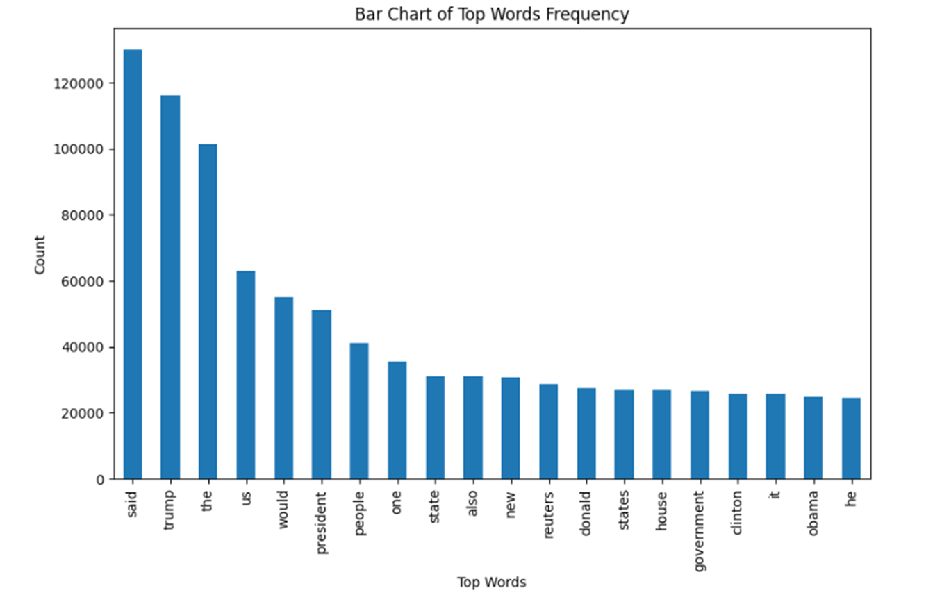

**CONCLUSION:**

In the era of digital information, the ability to discern fact from fiction is more critical than ever. Advanced techniques for fake news detection are essential tools in preserving the integrity of information and ensuring a more informed and resilient society. However, it's important to recognize that no single technique is foolproof, and a holistic approach involving technology, education, and media literacy is necessary to address this complex issue effectively.